- Purpose
  - The purpose of this document is to describe the procedure for quality checking a propane burnisher.
- Scope
  - This SOP applies to all equipment assembly team members. The process applies to the following machines:
E012800EQM0600BE1200 – 21” Optima XR
E012805EQM0600BE1200 – 21” Optima XR w/ Clutch
E012815EQM0600BE1200 – 21” Optima XR w/ Emissions & Clutch
E012830EQM0600BE1200 – 27” Optima XR
E012835EQM0600BE1200 – 27” Optima XR w/ Clutch
E012840EQM0600BE1200 – 27” Optima XR w/ Emissions
E012850EQM0600BE1200 – 27” Optima XR w/ Dust Control
E012860EQM0600BE1200 – 27” Optima XR w/ Clutch & Dust Control
E012865EQM0600BE1200 – 27” Optima XR w/ Emissions & Dust Control
E012875EQM0600BE1200 – 27” Optima XR w/ Emissions, Clutch, & Dust Control
- Responsibilities
  - The operations manager/supervisor is responsible for enforcing this SOP.
- Materials
  - The proper materials needed for this process are listed on the machine work order.
- Definitions
- Procedure
  - Check the machine over and see if there are any visual issues with the machine (Dirt, loose wires, parts missing, etc.).
  - Install, connect, and open the valve of a test propane tank.
  - Connect the tachometer to one of the spark plug wires.

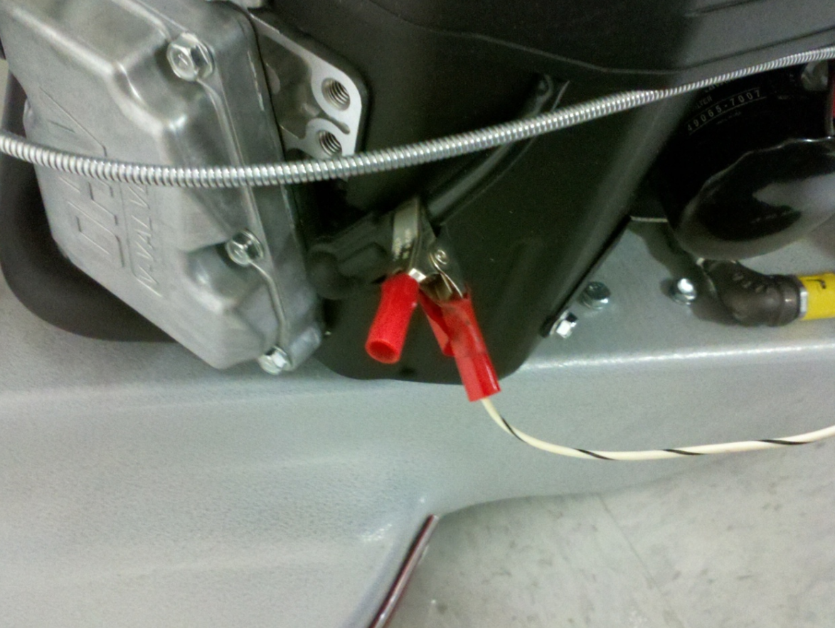

  - Make sure that the machine is tipped back and resting on the transport wheel. Start the engine and set the throttle speed to the idle position.
  - Set the idle RPM of the engine. It should be set to 1800rpm. This is done by adjusting the idle adjustment screw shown in the photo below. Be sure to tighten the nut back up when complete. The engine may spit and sputter a little at first. It needs some time to warm up.

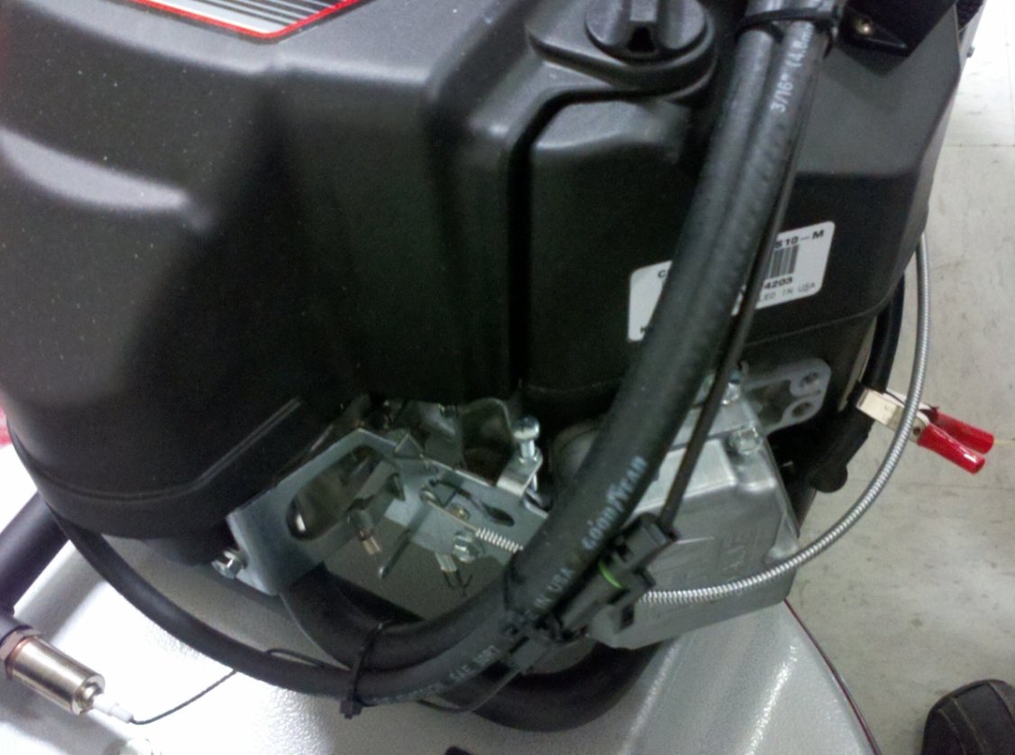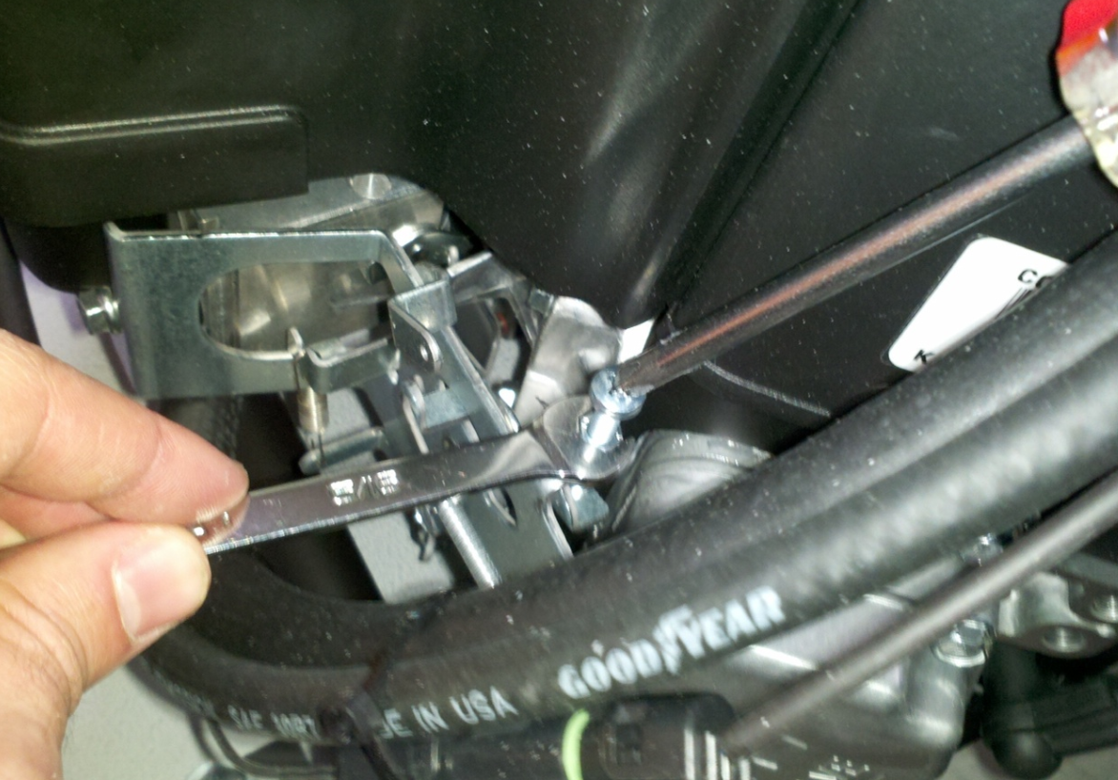

  - Throttle up to full. The RPM of the engine should be around 2800 rpm.
  - Operate the machine in its intended manner with the pad on the floor. Be sure to verify the handling of the machine. Stand still and slowly drop the pad onto the floor. The machine should naturally start to pull itself forward with only a slight right or left pull. If the machine pulls hard to the side, does not pull forward (boggs down or pushes backwards), or bounces, it will need to be reshimmed. Take the unit back to the assembly team to do this.
  - Run the machine for 1-2 minutes and note any abnormalities in handling, engine sound, etc.
  - Place the machine back on its transport wheel and put it back into idle throttle. Double check the RPM’s at this point as it may need to be re-adjusted back to 1800rpm.
  - Once that is complete, shut the machine off and remove the test propane tank.
  - Put together a manual packet for the machine. This includes a machine manual, a Kawasaki engine manual, a Kawasaki Warranty form, a Betco warranty registration card, and a tech service card. This should all be put in a bag and shipped with the machine.
  - Stage the machine for packaging.

- References (optional section as needed)

- Training Guide

Functional Training Groups Requiring Training
Equipment Assembly Group

- SOP Change Control

Date of Change | Reason for Change
Rev 01 - 11/18/2013 | This is the first version of the S.O.P. hence there are no revisions to this document.
Rev 02 - 1/16/2018 | Added the responsibilities Section
Rev 03 - 4/4/2018 | Added updated handling instructions and corrections
Rev 04 - 5/4/2018 | Updated for the Optima XR upgrades
Rev 05 - 3/14/2025 | Updated for Onyx engine

Approvals

Submitter/Author Approval:__________________________________ Date:______________________

Management Approval:______________________________________ Date:______________________

QAU Approval:_____________________________________________ Date:______________________

